Autoscript for set actual dates from sched dates when complete wo setup:
1.Go to Automation Scripts app, Create a script
Select Action Create Script with Attribute Lunch Point as following info, object WORKORDER, attribute STATUS, lunch point variable say status

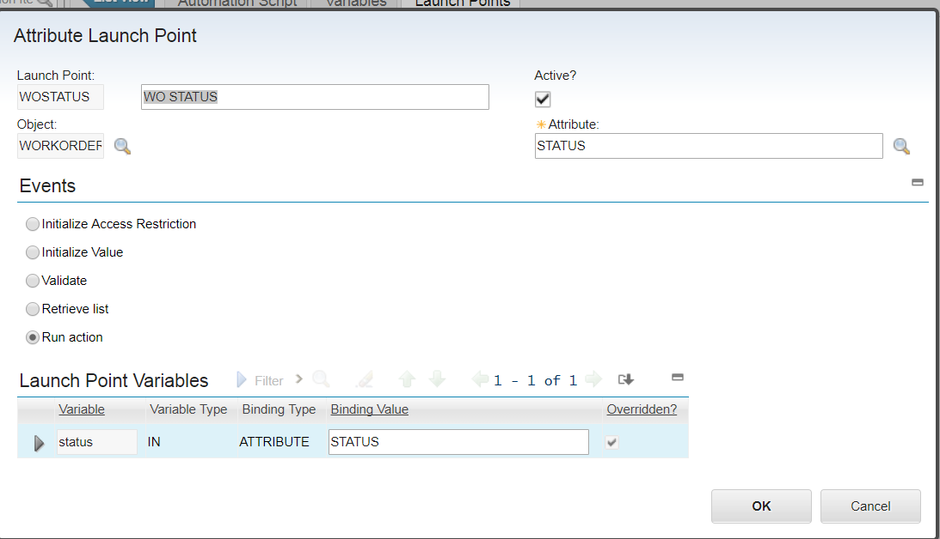

2. script context, if the complete status have synonym, you may change the 'COMP' to the one you have.

if status=='COMP':
mbo.setValue("ActStart", mbo.getDate("SchedStart") )
mbo.setValue("ActFinish", mbo.getDate("SchedFinish") )

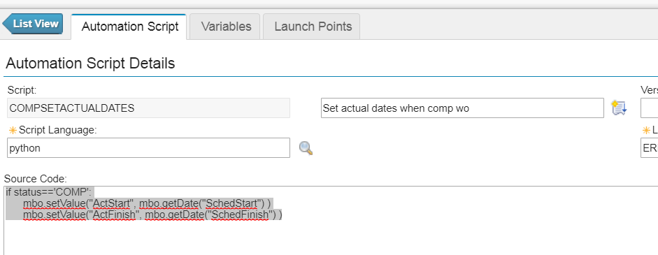

3. go to workorder, when change straus to complete, actual dates shold be set to sched dates:
